Appendix X

**Time Plan**

The time plan of this project has been modified multiple times. Both initial time plan and timelines with descriptions are included in this section. The timeline of the project was illustrated first in a markdown file then is managed in a Gantt chart. The Gantt chart was made with Microsoft Excel. By typing in the start period and duration, the chart will show the bar of a corresponding length automatically. The bars in different colours denote different status. Purple refers to complete status, and yellow represents beyond plan. Team 10 utilises this tool to trace and manage the work with plan.

**Initially Estimated Phases**

The team initially made a rough time plan structure with estimated time period after each phase. This time plan functions as a base of the project planning. The team has built a Gantt chart based on this plan and made several modification and addition to it during the development. The phases Research and Design go as planned. However, plan for Implementation was underestimated. Significant modifications was done to this part after the design phase.

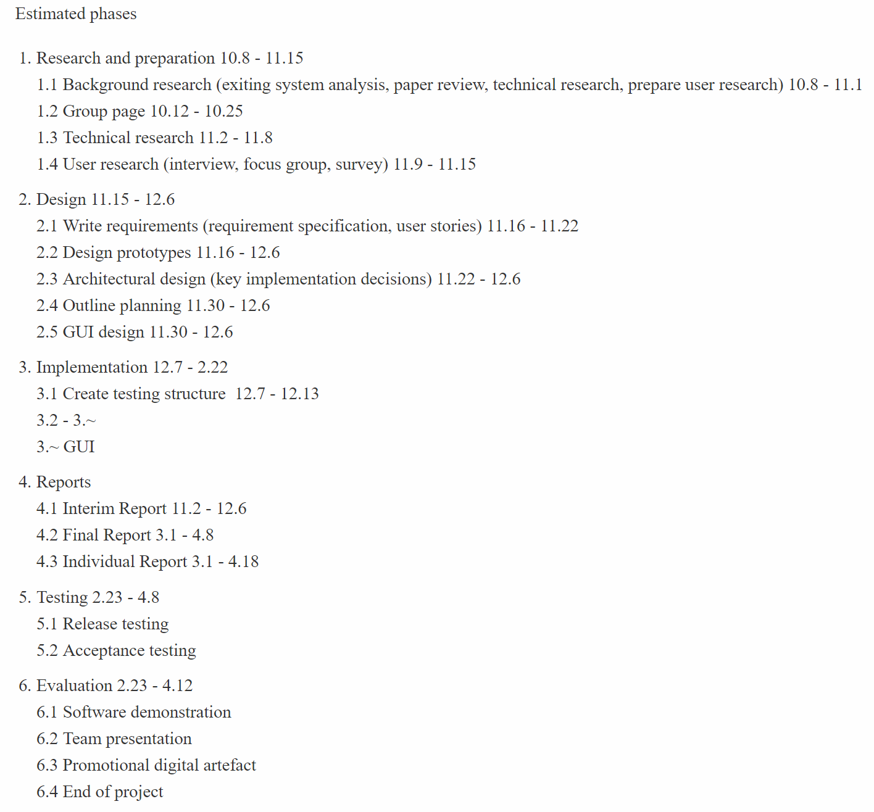

Figure 1. Initially Estimated Phases

**Gantt Chart**

[Original Gantt Chart – 用原来的第一部分]

[Interim Gantt Chart – 原来第三部分的图]

On 10th December, the team has finished the interim work mostly as planned. Moreover, the detail development plan for implementation has been made. This is illustrated in the third stage. The time plan with Gantt chart helps manage the progress of the project well. The team will utilise this tool in the following weeks to improve the quality of the work.

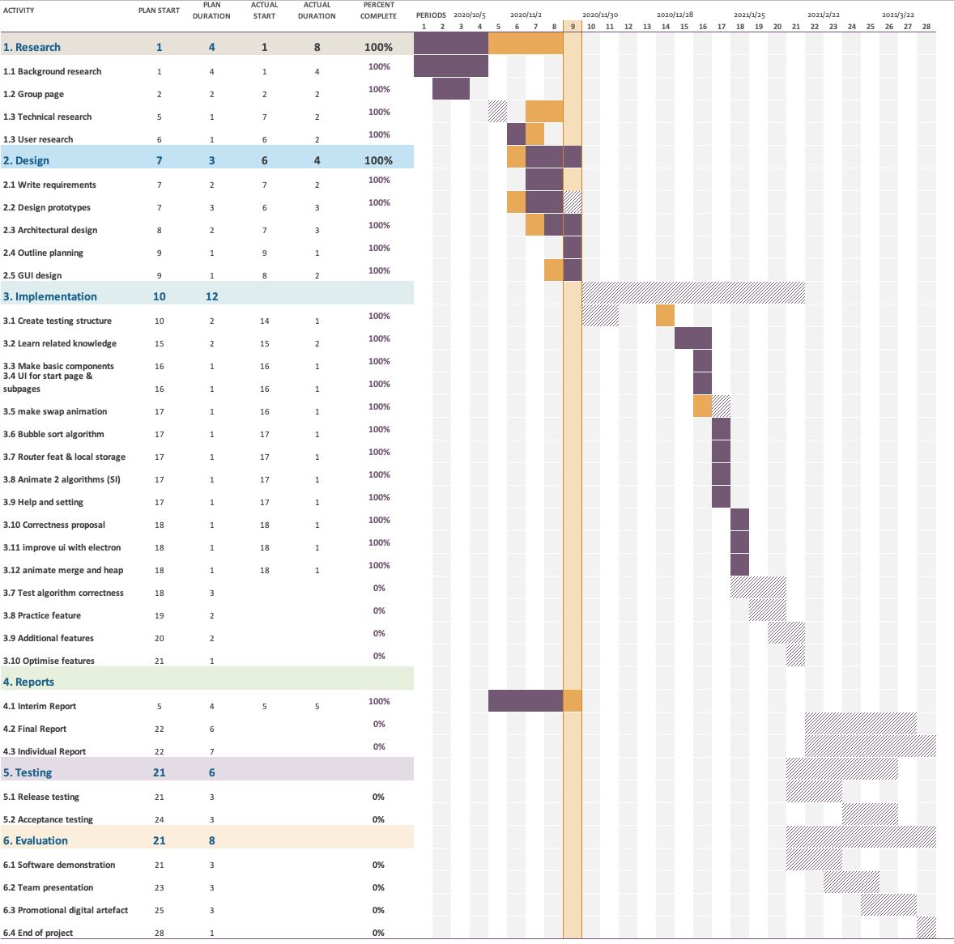

Figure3: Middle-Stage Gantt Chart

More detailed plans for implementation stage were made before each sprint i.e., each week. On February 12, the team has gone through 5 sprints and finished sorting visualisation part of the software. The software can perform smooth swapping animation to demonstrate the sorting process as planned. As the figure illustrates, purple blocks mean most of the activities were finished on time.

--------------新加的------------

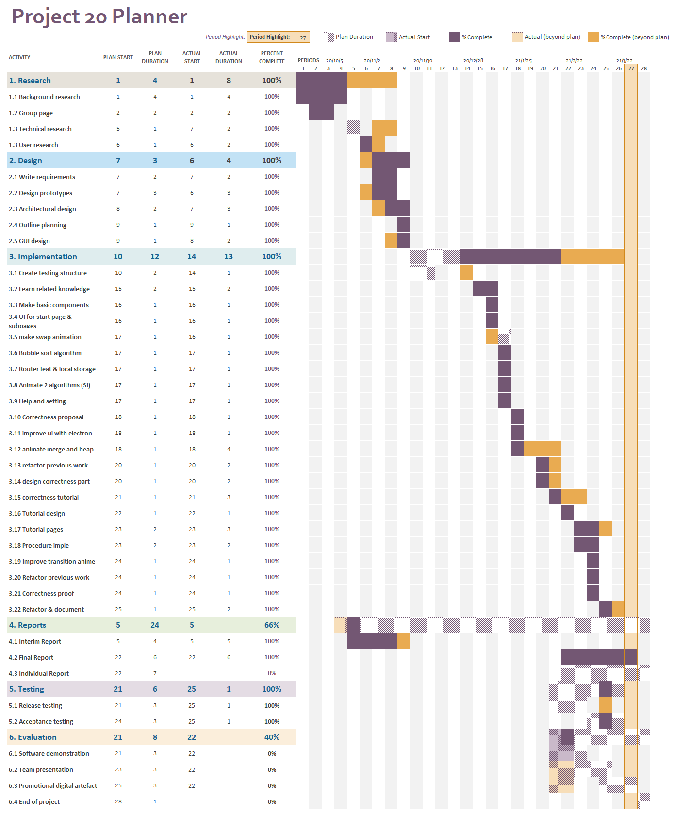

Figure 1.4： Time Plan on 9th April

At the end of the stage of software development and final report, the Gantt chart is illustrated in Figure 1.4. All the implementation tasks were finished by 4th April. The implementation stage was planned to start on 7th December. However, due to insufficient technical research, it was postponed for four weeks. Although we start coding late, the overall duration was still almost as planned, being 13 weeks. Among 22 tasks in the implementation stage, only seven of them were completed later than planned. The final report was finished as we scheduled. The time plan was overall suitable for the project and guided the team to finish the project on time. As a reflection point, a better performed technical research would result in more time for improving the software and preparing for the presentations.